Invoice Management System

Groups:

1. Admin
2. Staff
3. InvoiceApprover
4. Supervisor
5. InvoiceApproverAdmin
6. DepartmentAdmin

# **Admin:**

## Dashboard:

* Navbar 1. Welcome Name (Group Name) and on the right side 2. Profile including image, user Admin company name and logout

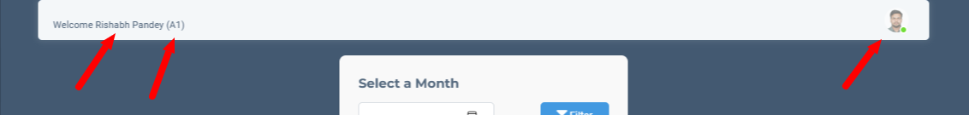

First arrow : Name

Second arrow : Group

Third arrow : Profile

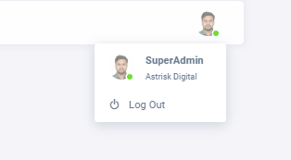

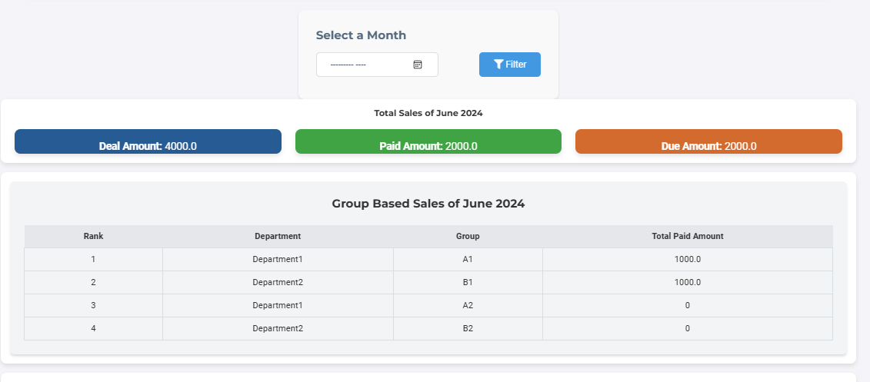

* Please first filter by month and select the month for which you want to see the sales data.
* Deal amount , Paid amount and Due amount is shown for the selected month
* In the Group based sales are shown with highest sales at the top ranking wise, with associated departments with group and Total paid amount.

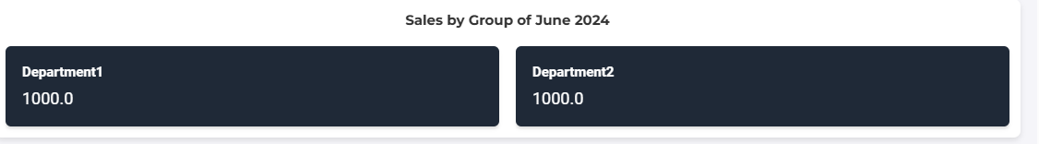

This is department wise sales of the specific month

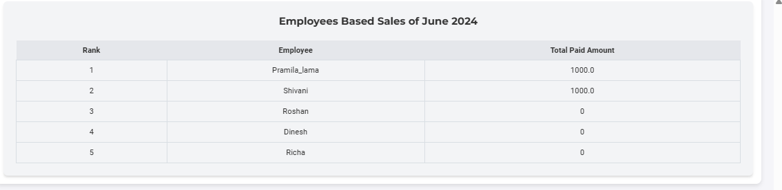  
This is employee based Sales of the Specific month. Here departmentAdmin and Staff is Employee

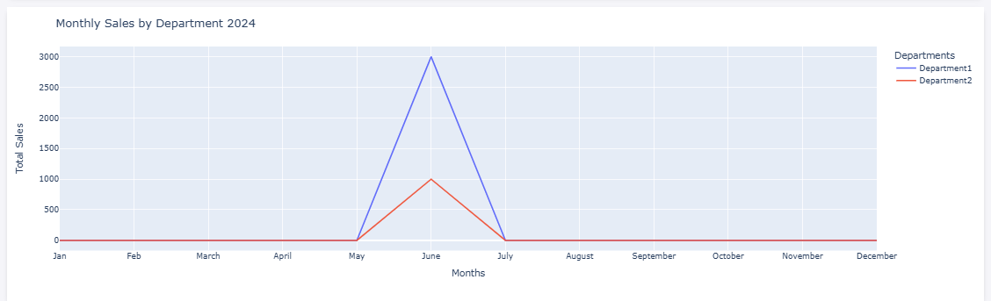

=> this is Graphical form of the representation of the Total Sales with Month

=> the line shows the name of the department with different color

=> On the right corner there is a section to select the department or unselect the department by clicking in the Department and on the basis of this the graph is shown with the department.

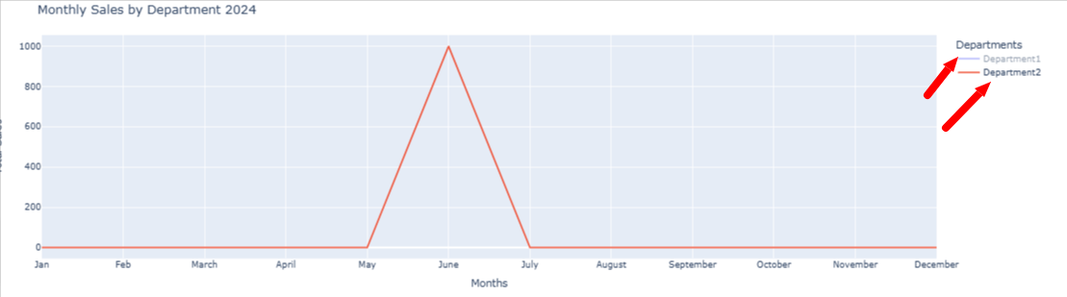

Here, When I unselect department 1 only department 2 is shown in the graph.

## 

## Your information :

=> Here in your information section, there is Image,Name,Email,Phone number, Pan card number, Address of the User.

## Departments:

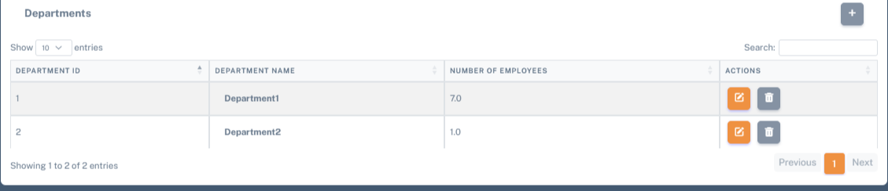  
  
=> This is a department view with the department name and number of employees in the department with an action button where the edit and delete option is there.

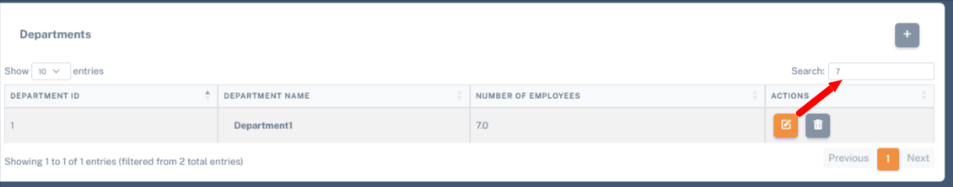  
=> search section : search on the basis of department name or number of employee   
Eg: as shown above i searched on the basis of number of employees with employee number 7 the search result is shown above in the picture.

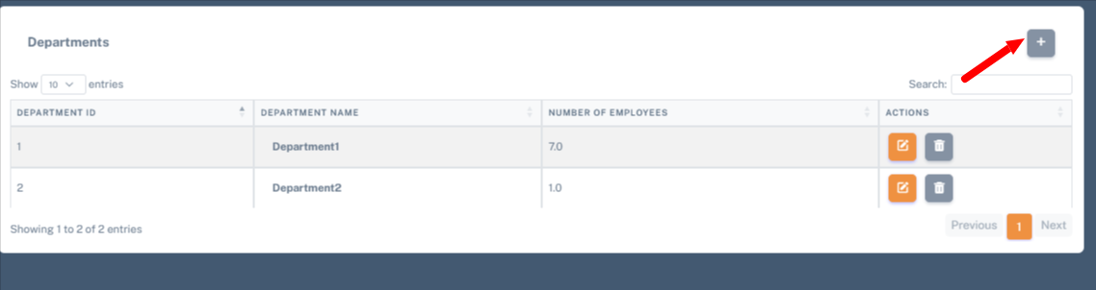  
  
=> The arrow point is to add department by clicking in the + button the Department form is appeared as shown in below

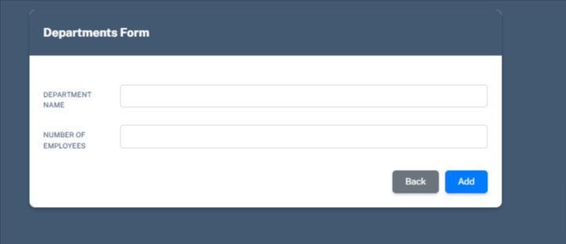

## Department Group :

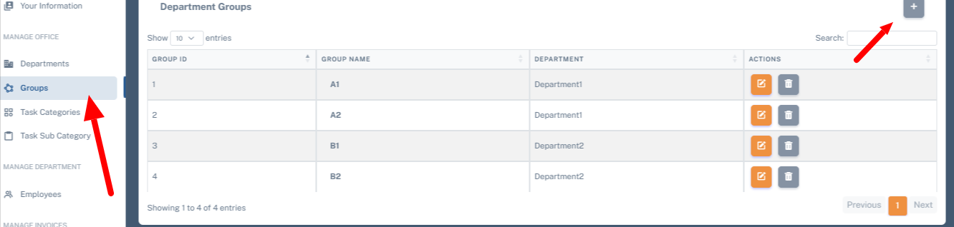

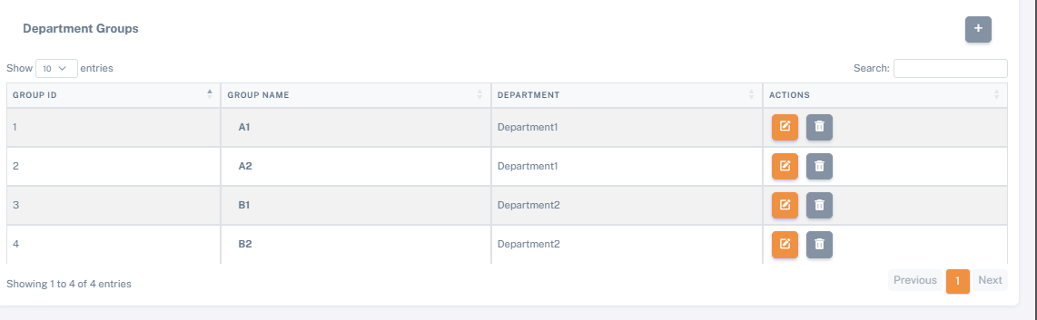

## Task Categories:

=> Here Name of the task is entered and on the basis of the task sub categories section where a task inside another task is mentioned.

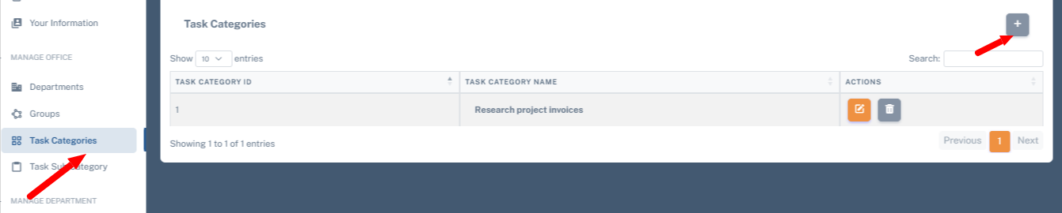

## Task Sub Category:

=> Task categories have sub task categories.

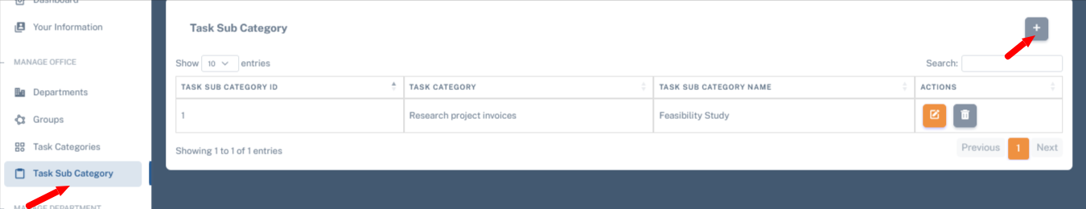

## Employee:

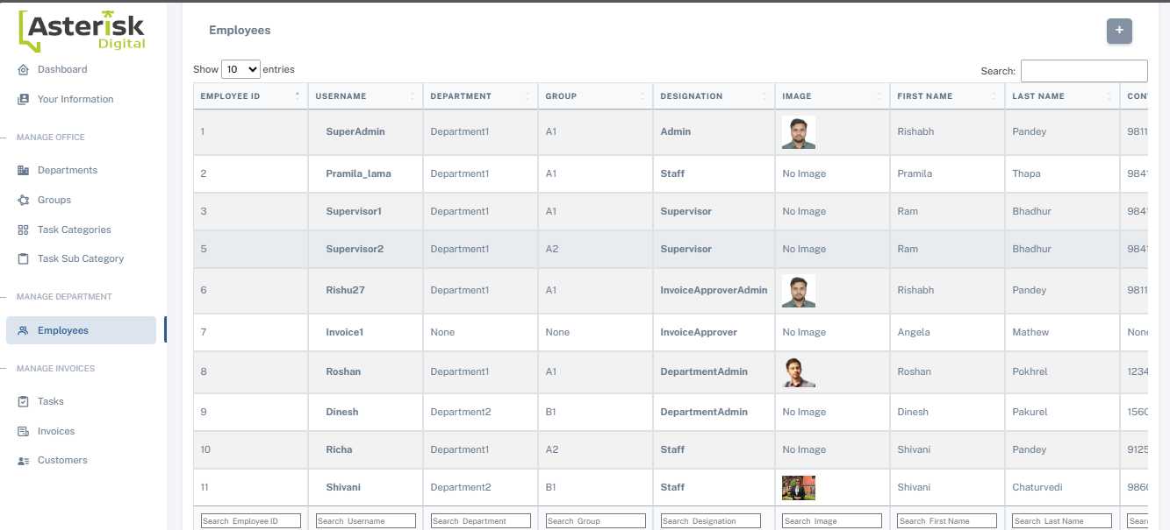

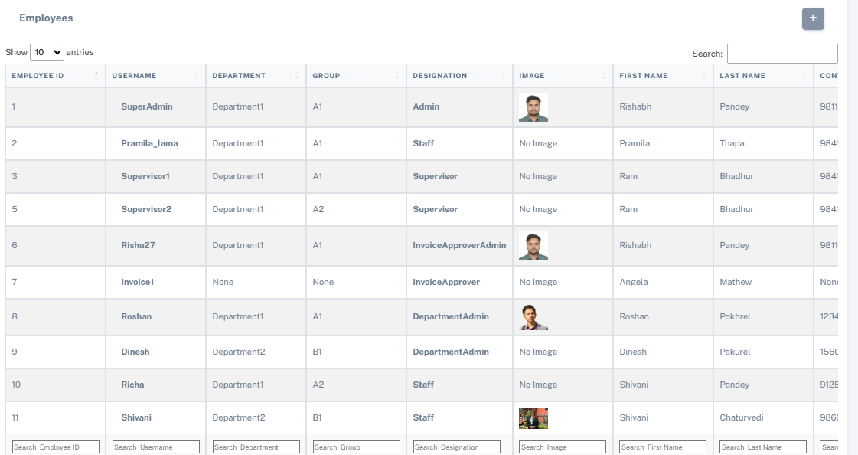

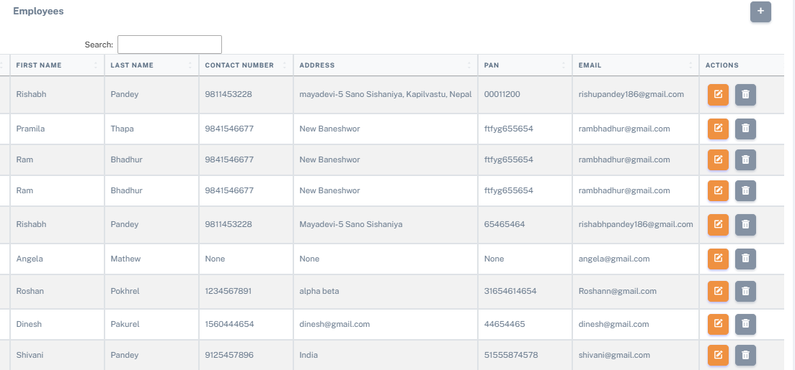

Employee have fields = ['username', 'first_name', 'last_name', 'phone_number', 'address', 'PAN', 'email', 'department', 'group', 'image', 'User Designation']

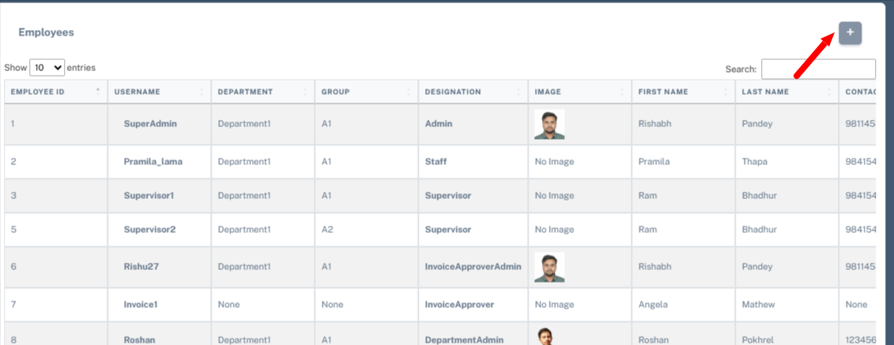

=> after clicking the + button the employee form appear as shown in below:   
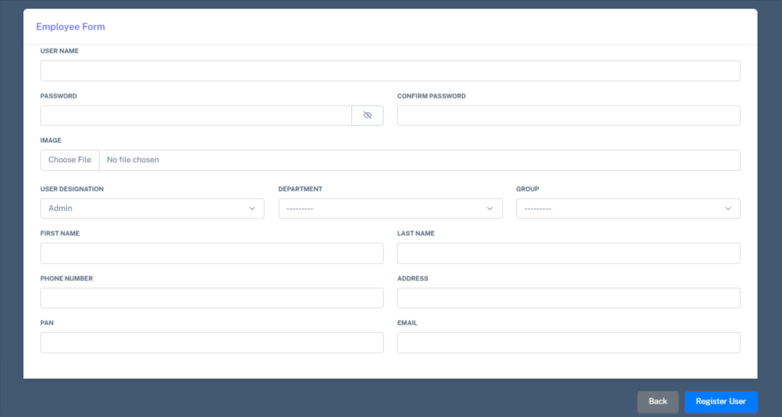

=> While filling form user should choose User designation   
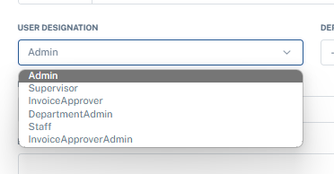  
After selection the User Designation, the user have to choose the department 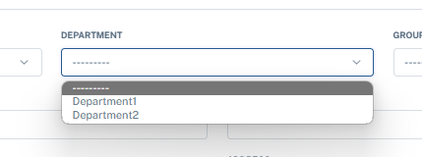

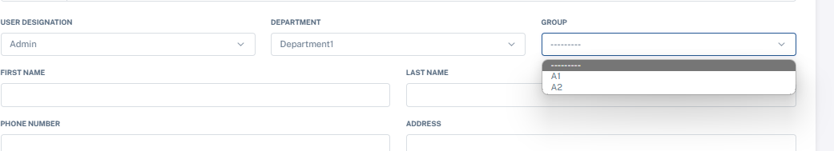=>After selecting the department the group associated with that department is shown in the group section and users have to choose the department group.  
  
Here users have to enter only a 10 digit phone number. Phone numbers less or greater than 10 digits are not accepted.  
  
After that the user clicks on the register button to register the user.

After the Registration successful the user with the username and password can login in.

There is also an edit action button where user details like username, password, image, full name,etc can be edited. And there is also a delete action button for delete the registered user.

## Customers:

In this section the customer is added with the Fullname,Employee , contact number , address and action section has edit and delete section.

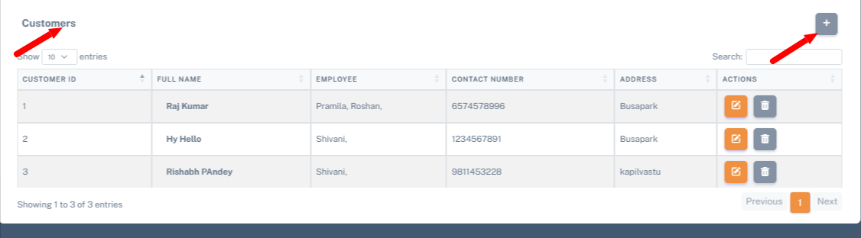  
After clicking add button

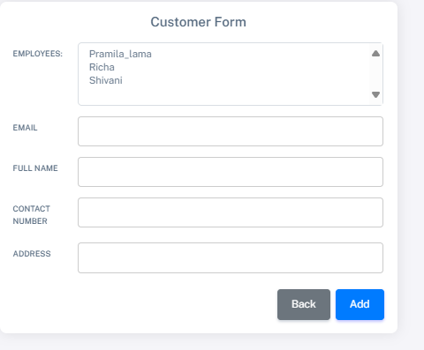  
This form appears after clicking the add button on the customer.

Here we have to select the employee which means Staff and on the basis of that staff the customer is created i.e Customer is selected on the basis of Staff.

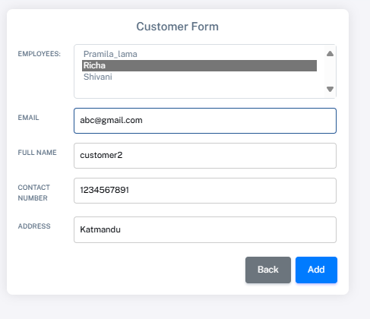

After click on the add button it should be visualize in the customer table as shown below in the picture:  
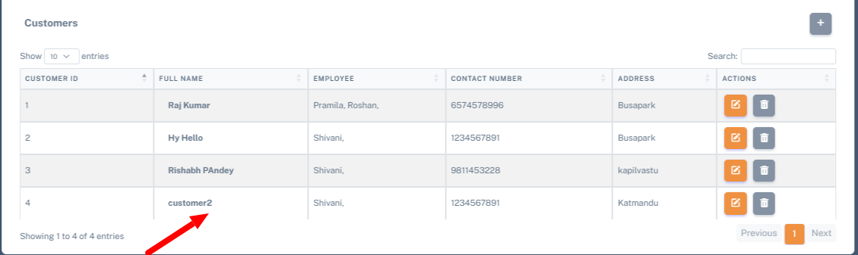

## Task:

After the customer is added. The tasks are assigned to the customer.

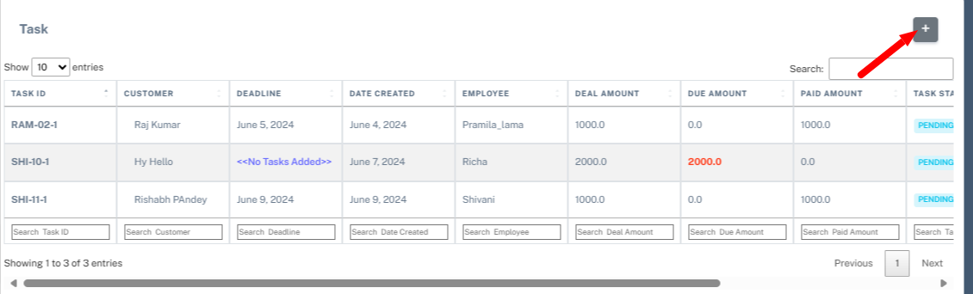  
=> This is view where the task is assigned to the customer with Task ID, Customer, Deadline , Date Created, Deal Amount , Due Amount, Paid Amount, Task Status , Invoice Status and Action section ((add subtask and invoice) is 1 , edit is 2 and delete is 3 )

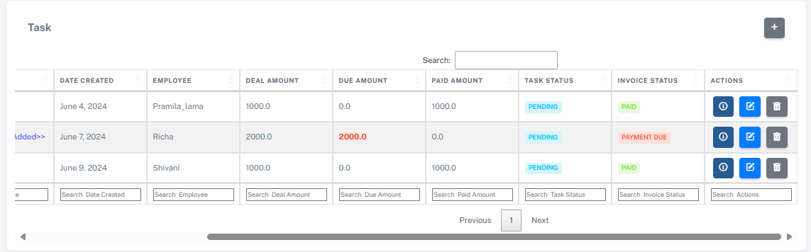

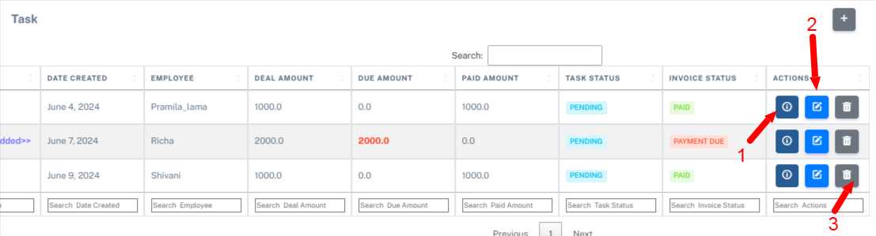

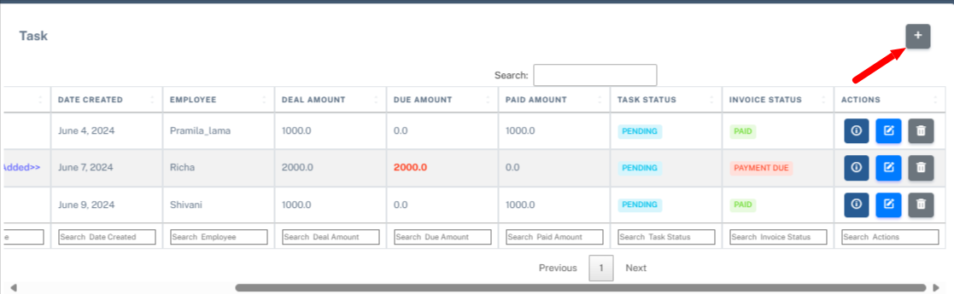  
After clicking the + button the task section is opened.  
  
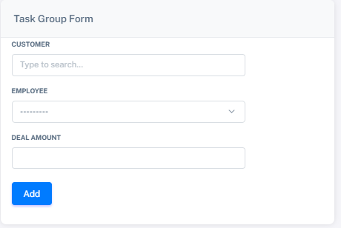  
  
After clicking in the Customer. Here we have to select the customer   
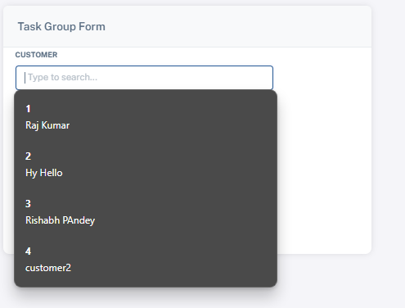  
When clicking in the customer section the customer is shown in the customer with customer id and we have to select the customer. After selecting customer we have to choose employee   
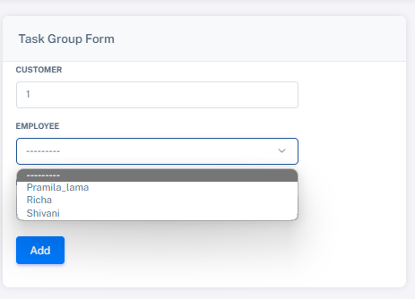  
After selection of the employee the deal amount should be entered   
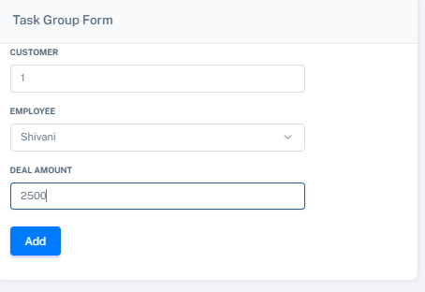

And then click on the add button and after it will be shown in the tasks section.   
Here you can see in the picture where arrow indicate   
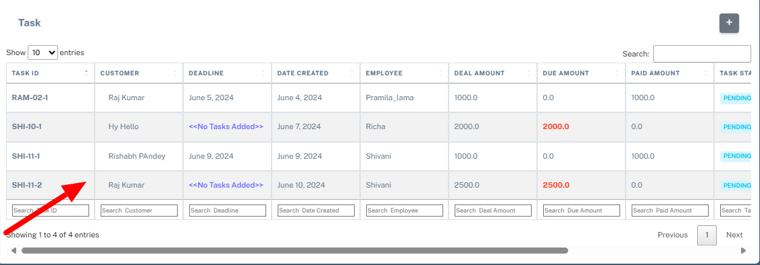  
  
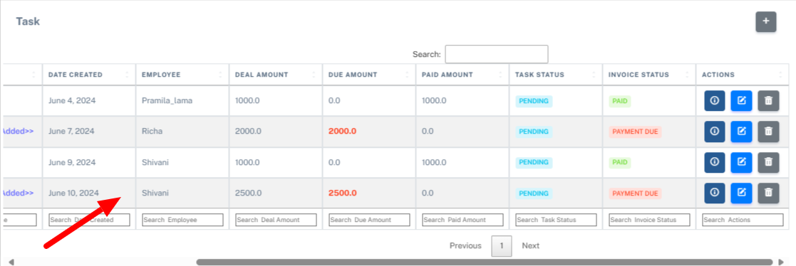  
  
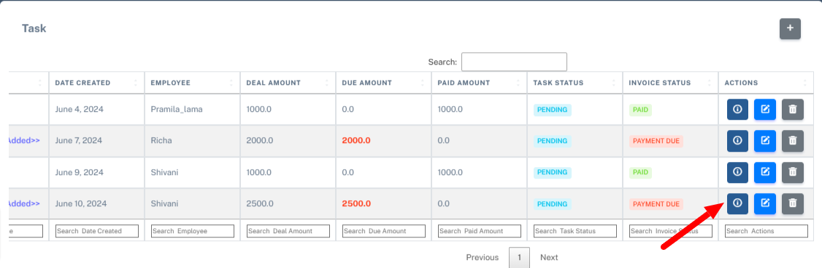  
=> When clicking on the arrow shown the task section and invoice is shown. Here we have to assign tasks and add an invoice  
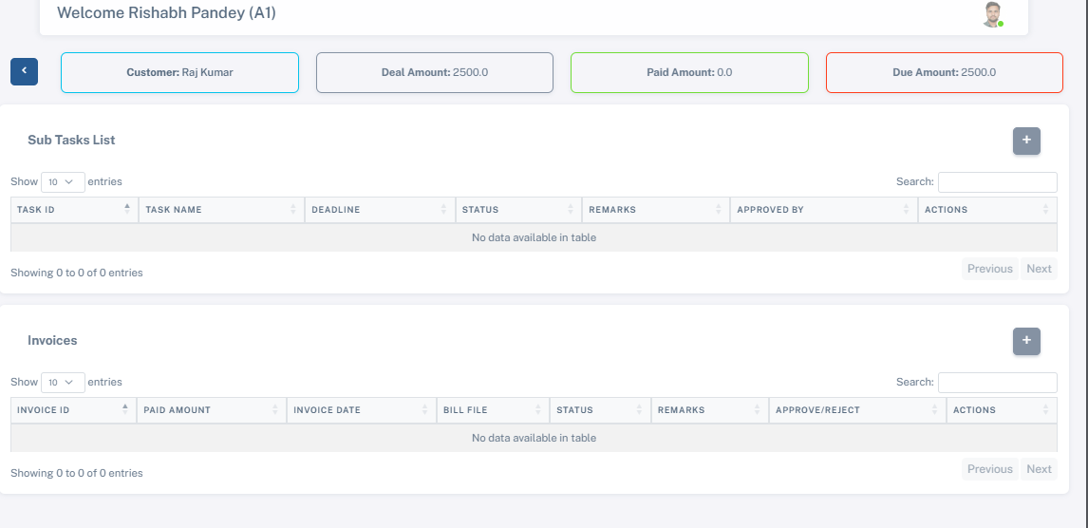=> Here in the top is the name of the customer with amounts shown.  
Then click on the sub task list to assign a task with the deadline   
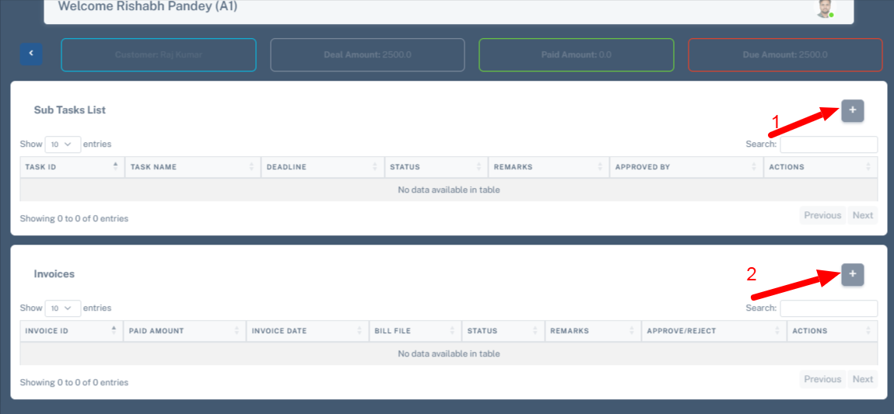1 is sub tasks add section and 2 is invoice is section.   
Lets click on the Sub tasks add section i.e 1  
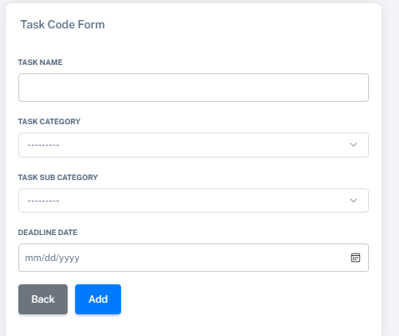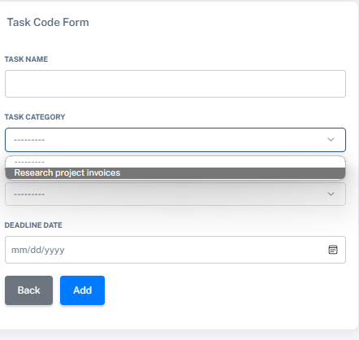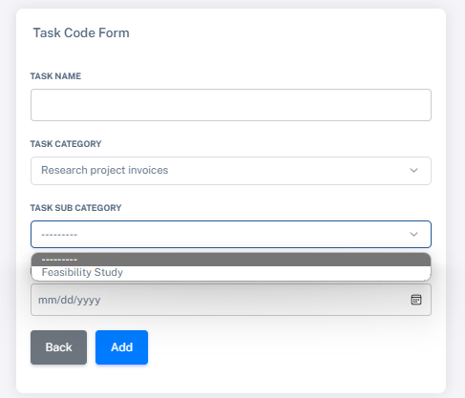se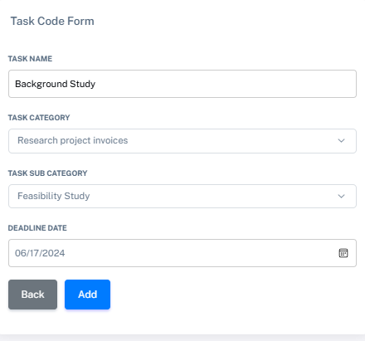  
Select the task name and then Select the task categories and on the basis of that sub task category is selected and the task deadline date has to be selected. Click on the add button to see the sub tasks list.

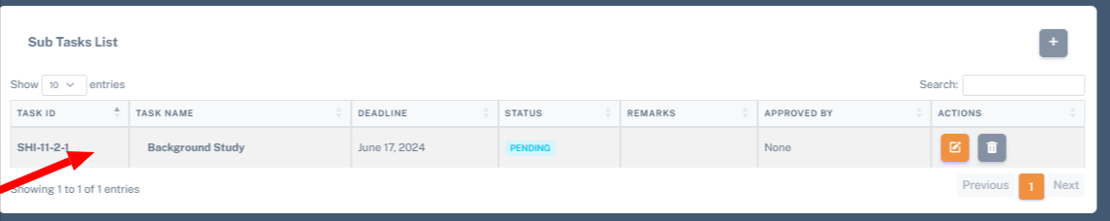

When click button invoice 2 to add invoice   
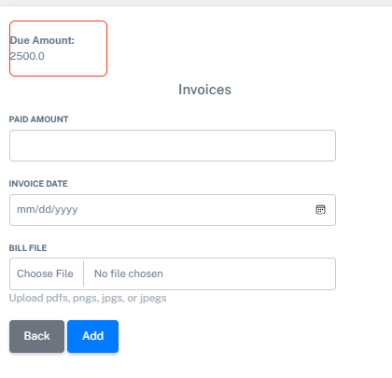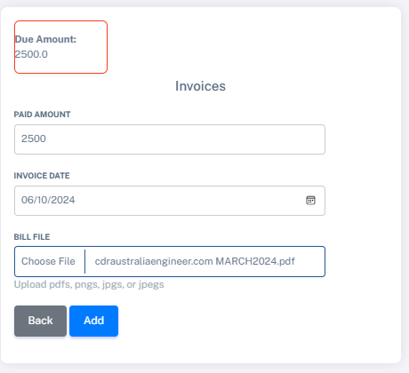

Here paid amount , invoice created date and the bill file has to be uploaded on the basis of bill file the invoiceApprover approves the invoice.

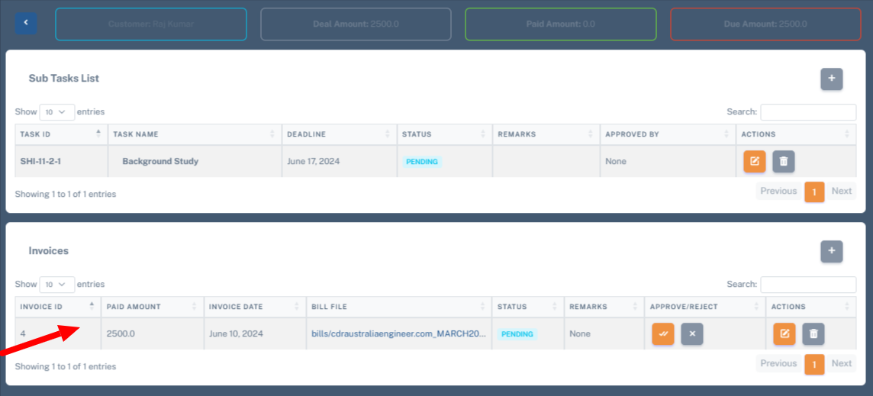

As this is the admin side the approve and reject button is shown. If the invoice is created by staff the approve or reject is not shown. It only shows the associated department invoiceApprover user for approve or reject invoices.

## Invoices:

Here invoice is stored as this is admin side dashboard so all the invoice is shown in the invoice with all the details:  
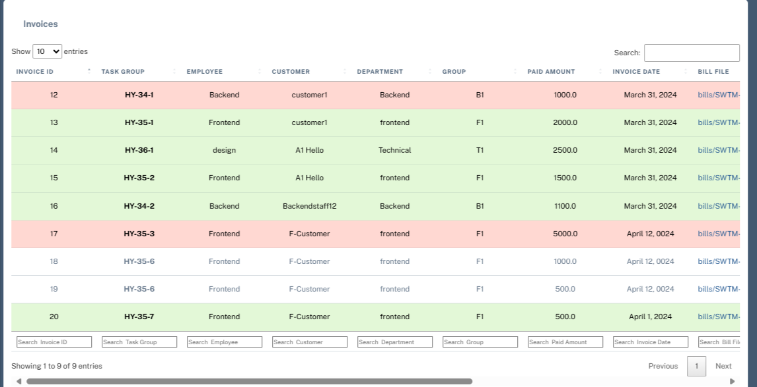

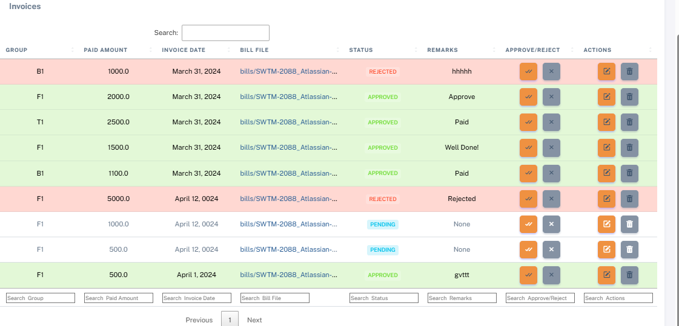

All the invoice status means rejected , pending and approved are shown with different colors.

An admin has the authority to accept or reject the invoice.

# **Staff:**

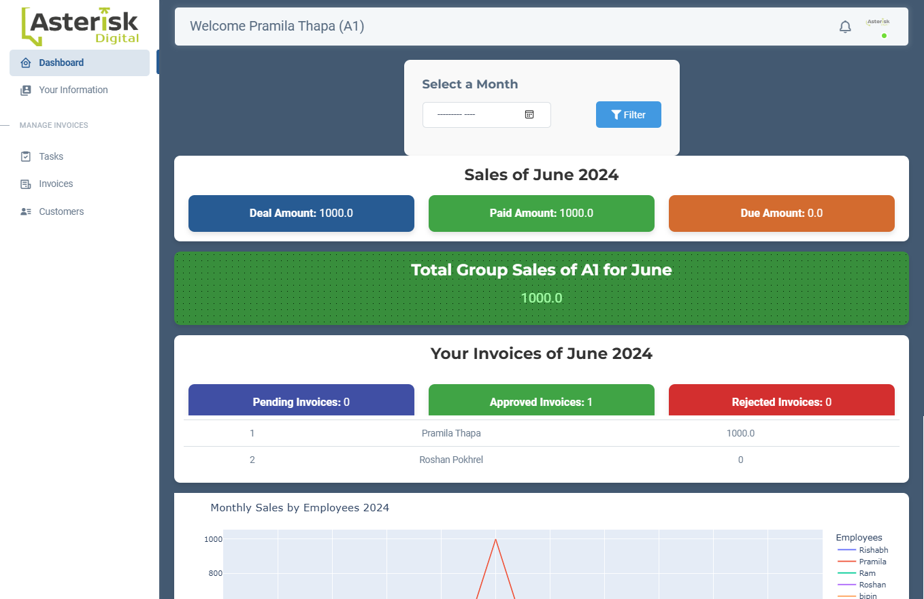

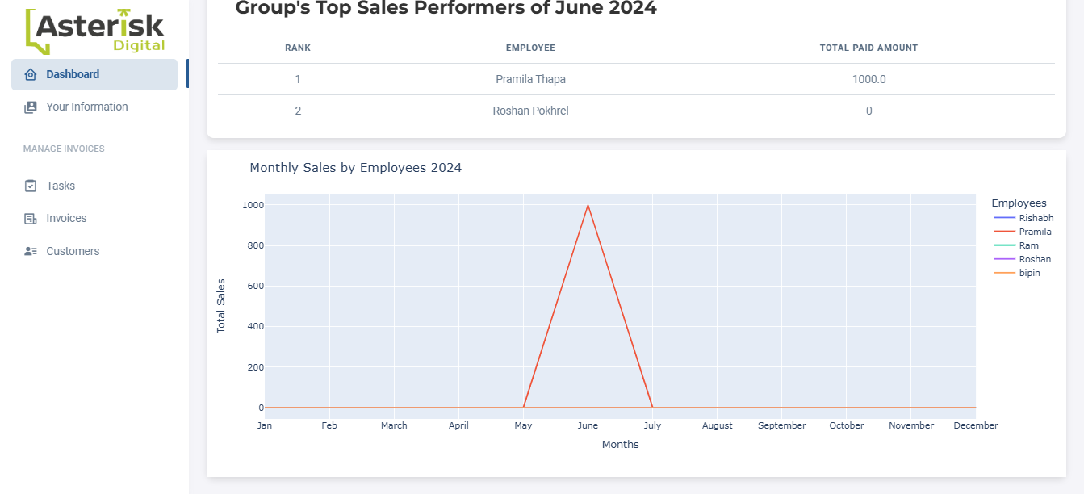

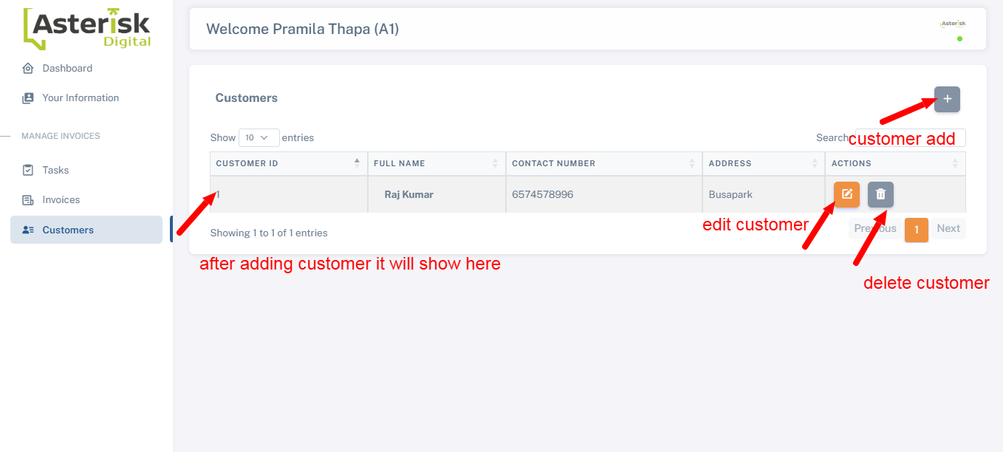  
After clicking add customer the customer add form appears.  
  
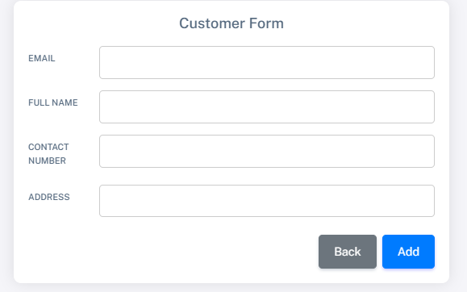

After that go to the task to add an assigned task to the customer.

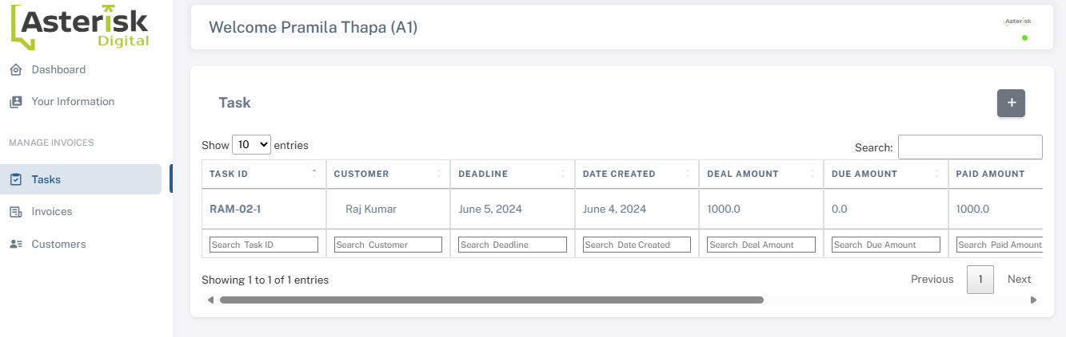after clicking + button

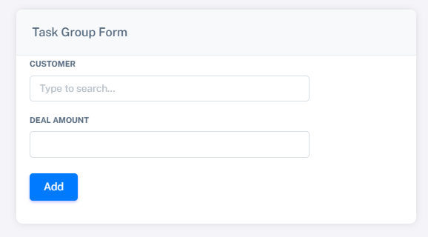.  
After add the task and deal amount then click add button

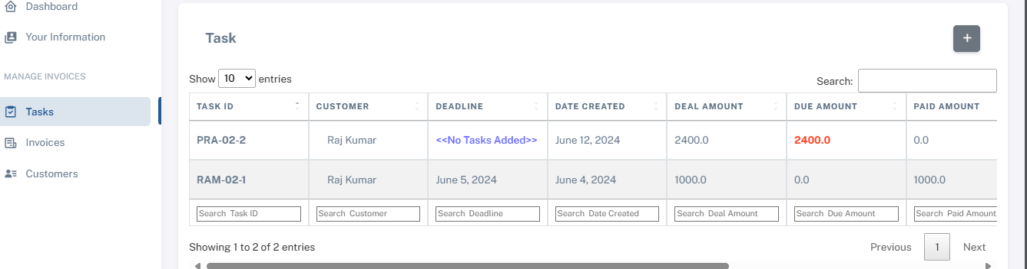

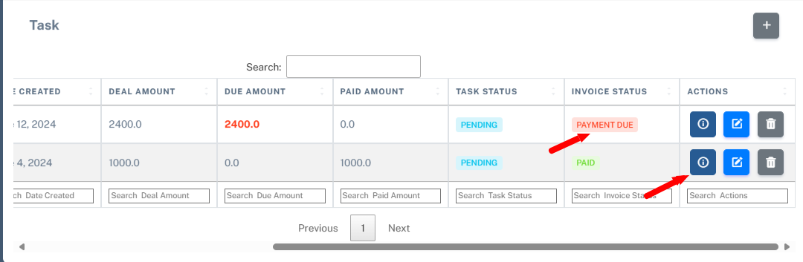

When clicking on the action first button the invoice and add subtask will appear, and add the task and create the invoice.  
When the invoice is created the invoice goes to the invoice approver after that when the invoice is approved by invoice approver the notification is shown in the nav bar section.  
Status will change to paid.

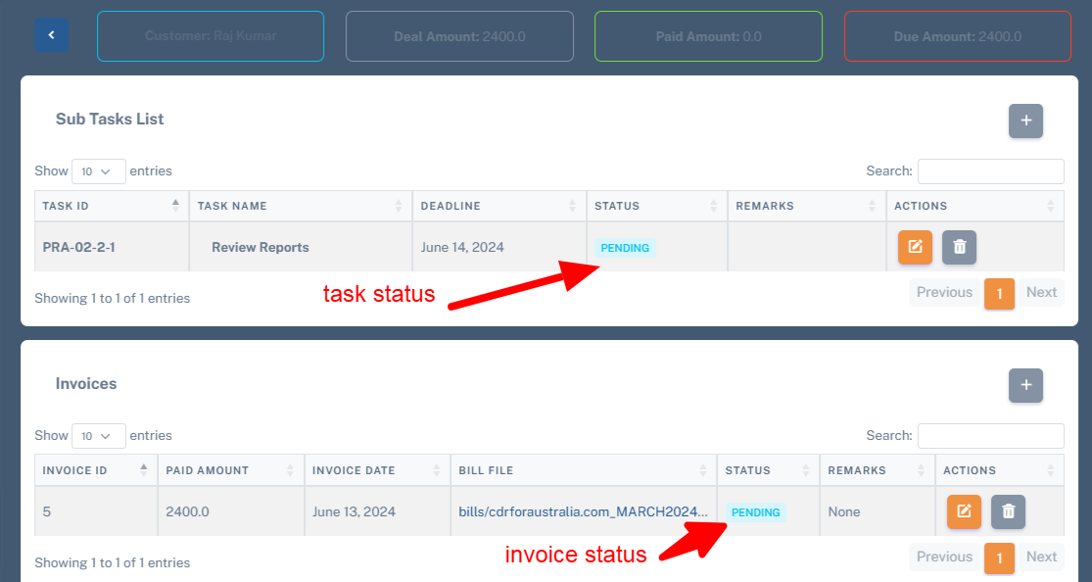

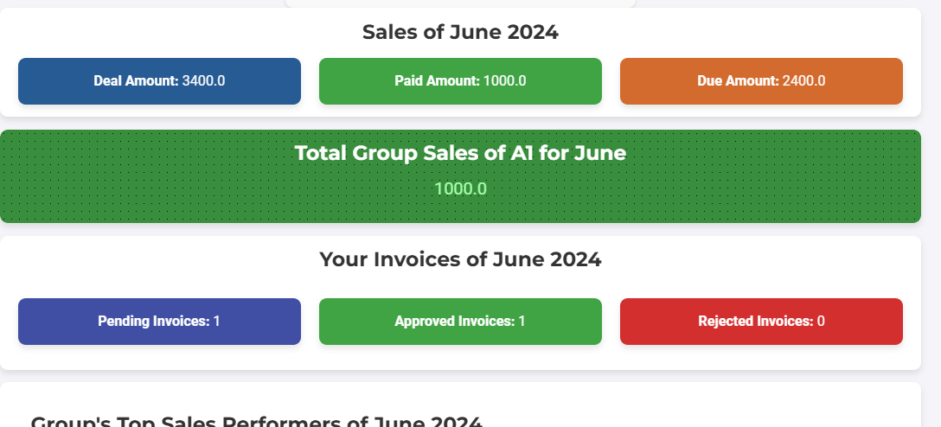

Let's log in to the invoiceApprover to see the invoice which was created by the staff.  
  
There are two invoiceApprover, first invoiceApprover is assigned on the basis of department and group, and the second InvoiceApproverAdmin.  
  
InvoiceApprover: Every department with a Group has a separate invoiceApprover.

Let's take an example, suppose Ram is in department1 and group A, and InvoiceApprover name Shyam is in department1 and group A invoiceApprover then when the Ram will create invoice the invoice will go to the InvoiceApprover Shyam.

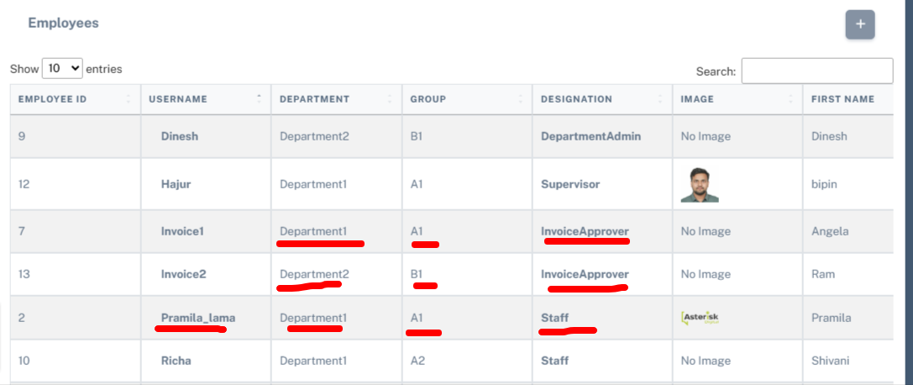

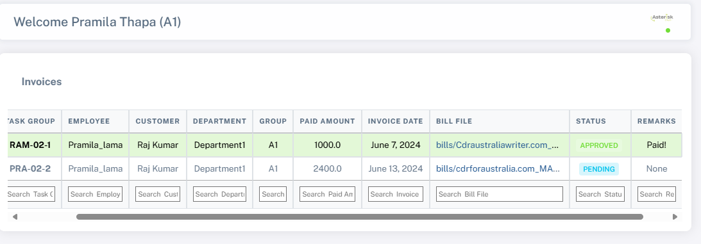

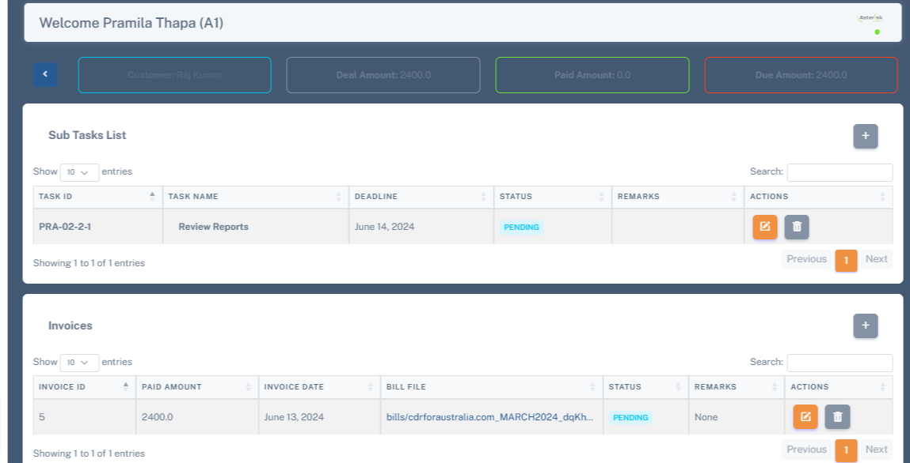

Here Pramila_lama is in department1 and group A.

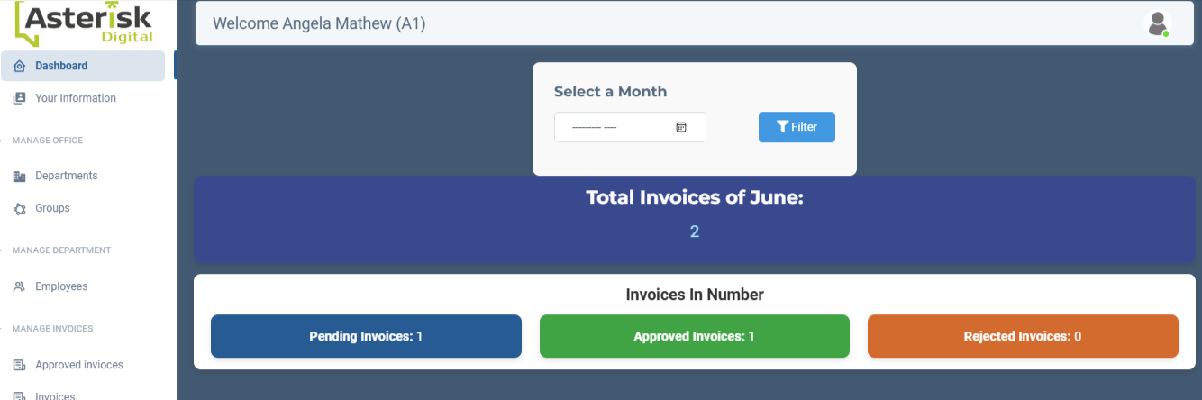

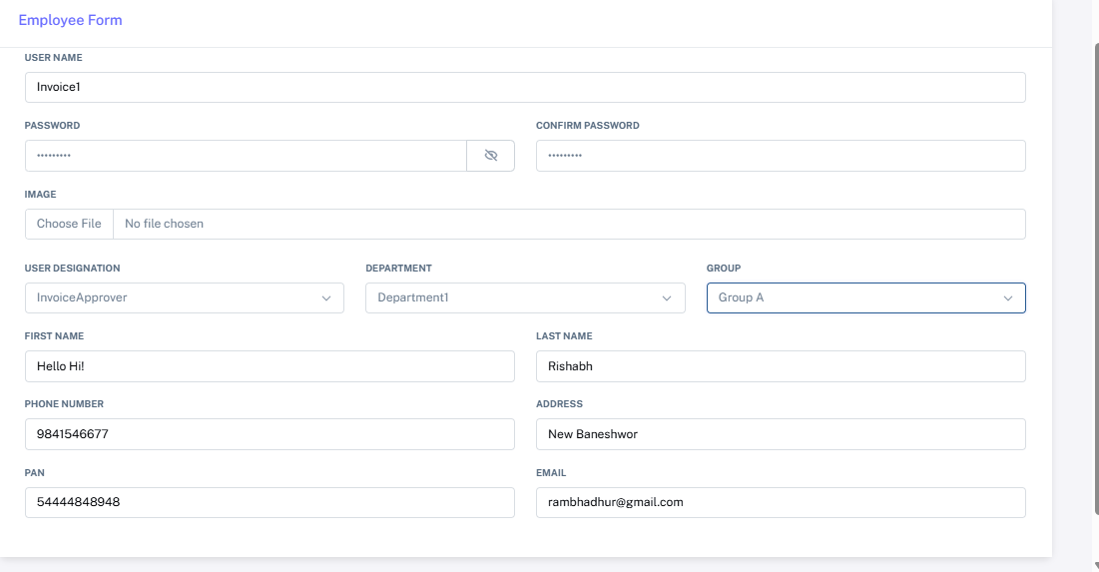

This belong to group A of department1

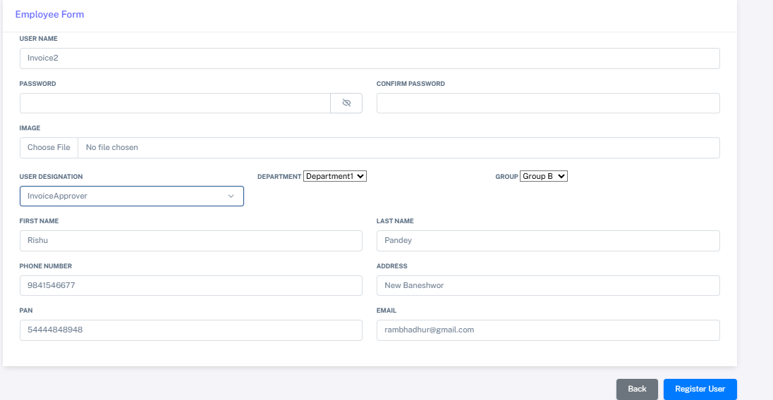

Group B

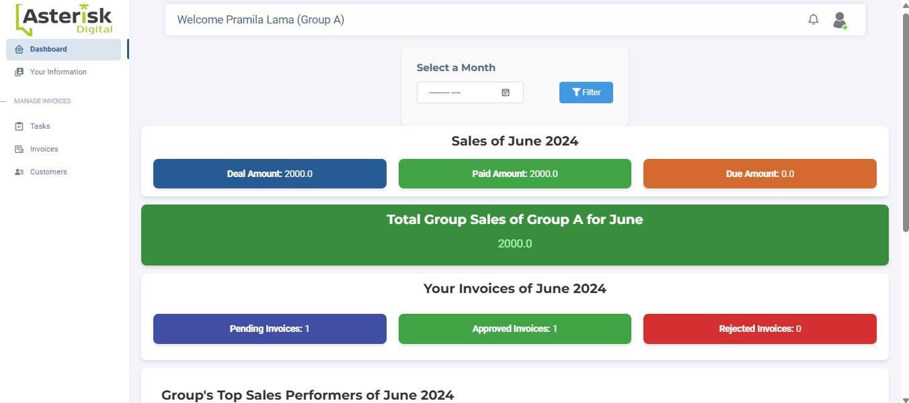

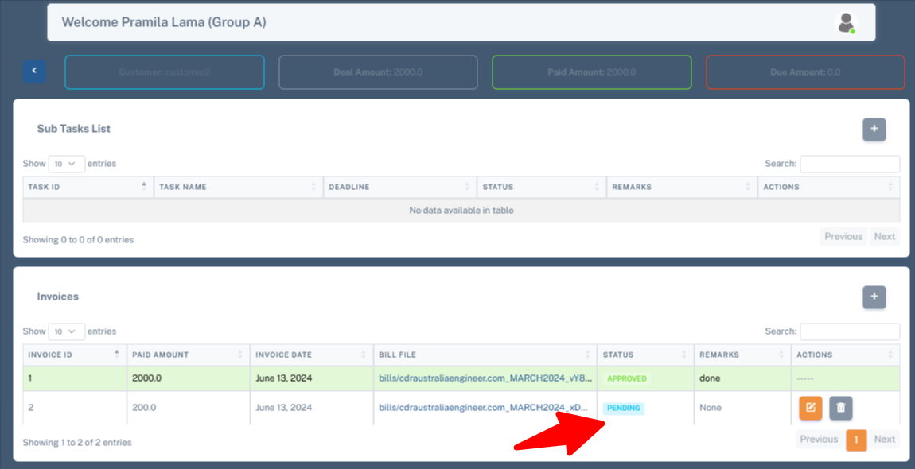Here

So let’s login to the invoice1 to approve the invoice

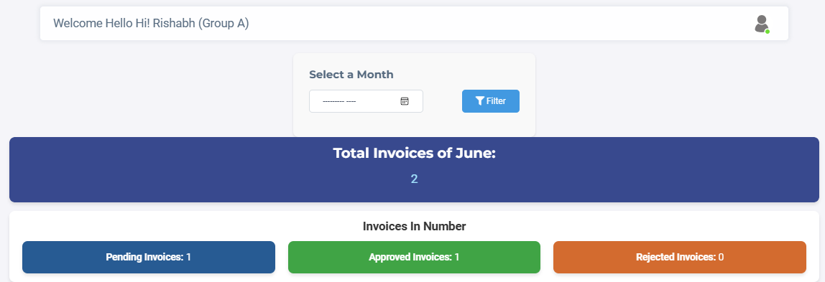

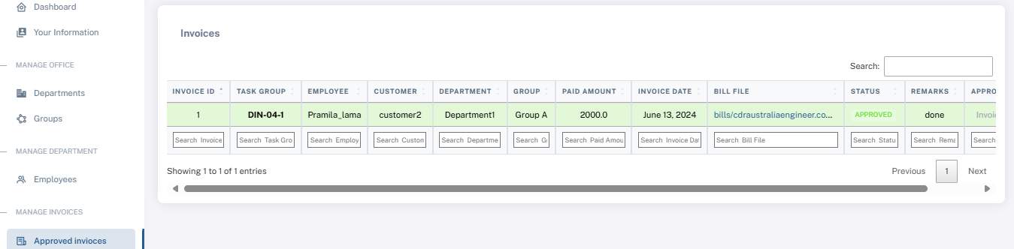

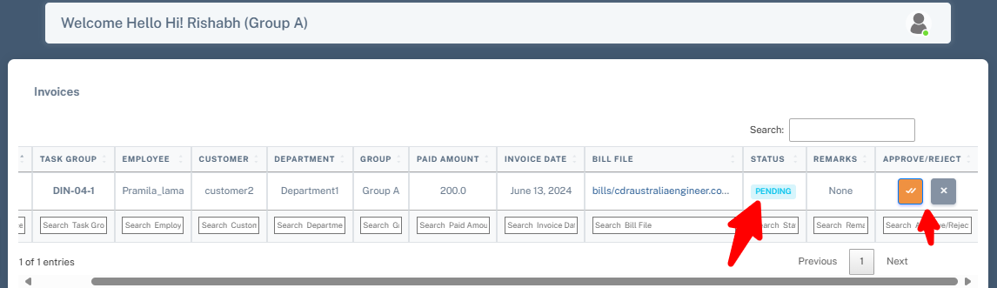

When the invoiceapprover Rishabh accept the invoice the notification is shown to the staff pramila lama and updated this invoice in dashboard.

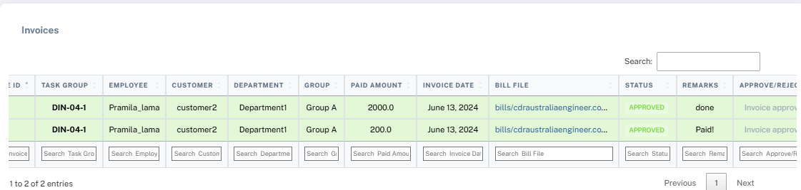

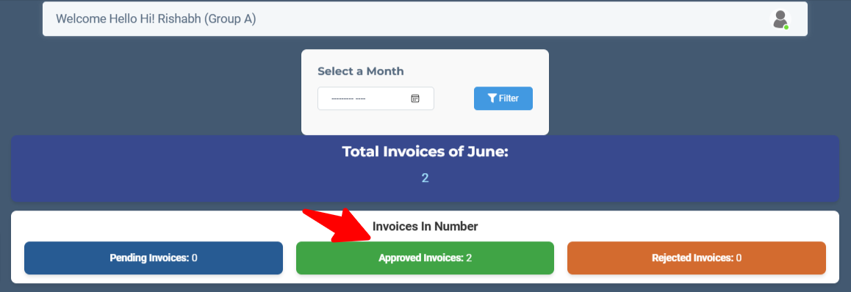

Let’s login to staff Pramila Lama

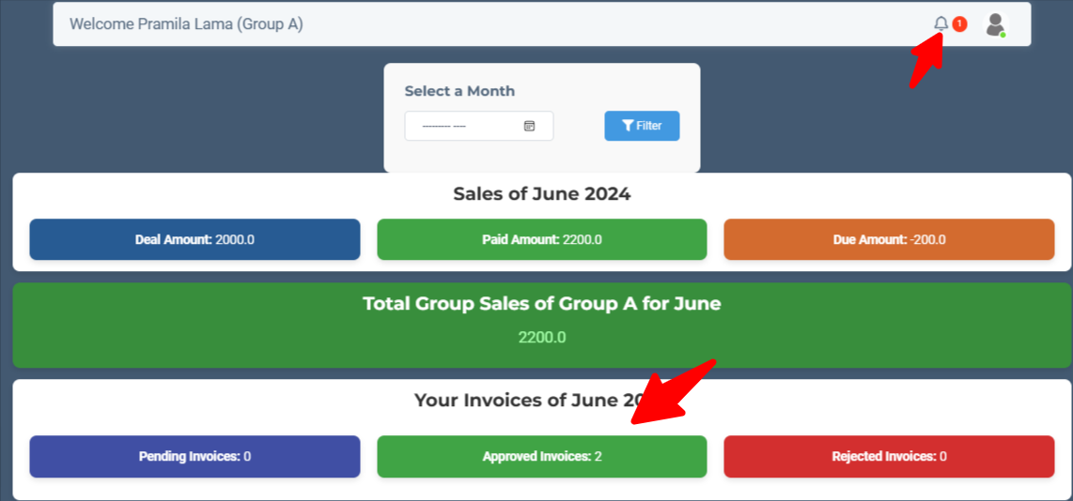

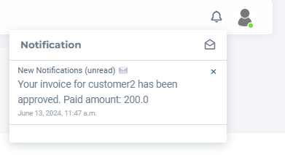

Let’s check on the dept1 having group B invoice approver Invoice2, there is no staff for this is assigned so no any invoice is shown on the invoice2 approver.

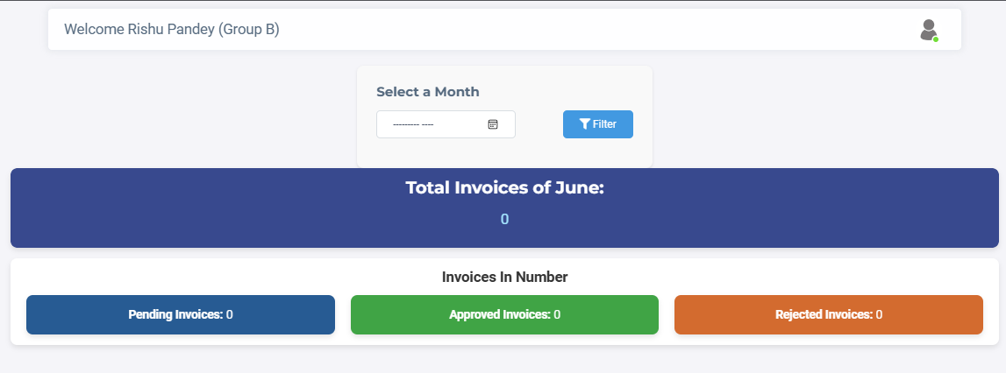

# Invoice Approver:

There is separate invoice approver with the department have specific group.

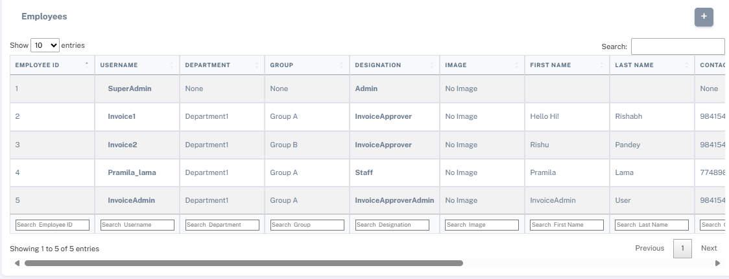

This is employee table having two separate invoice approver

Invoice1: is for department 1 group A

Invoice 2 : dept1 group B

Separate invoice approver has a separate department so when the invoice is created it will go to the specific invoice approver associated with the department and group.

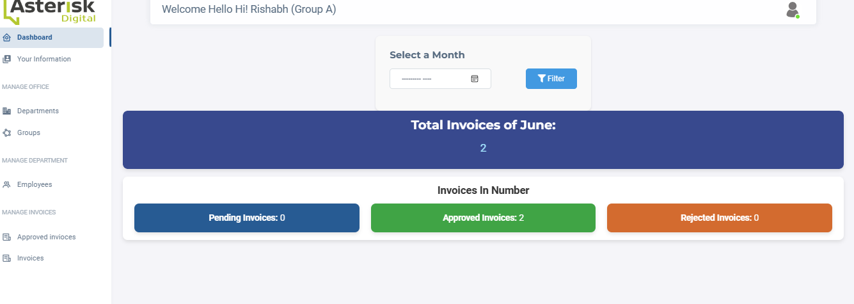

## 

# InvoiceApproverAdmin: This is admin for the invoice approver

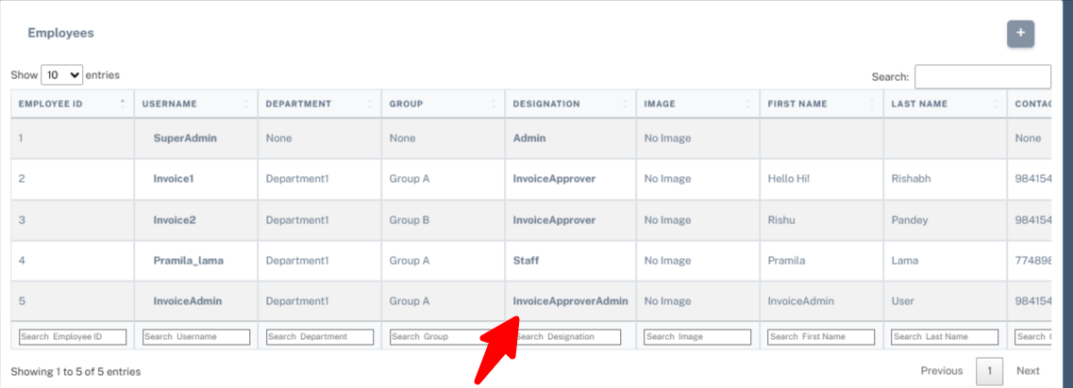

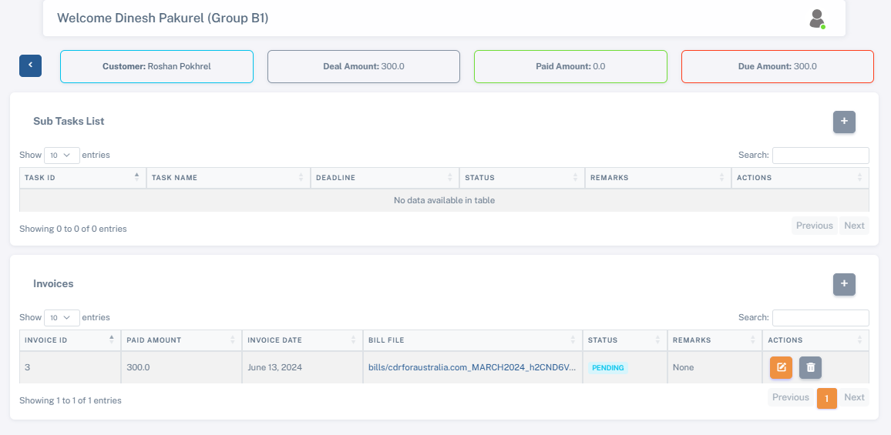

Department2 group B1

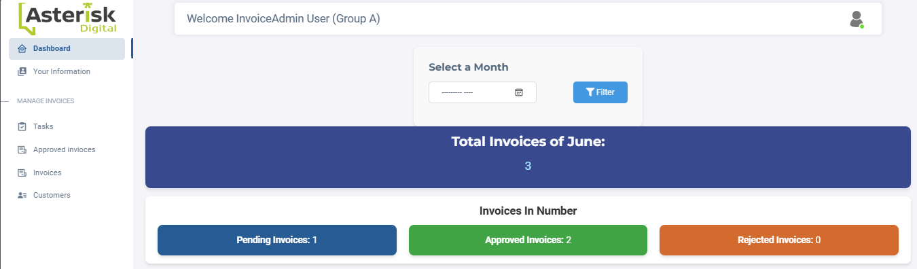

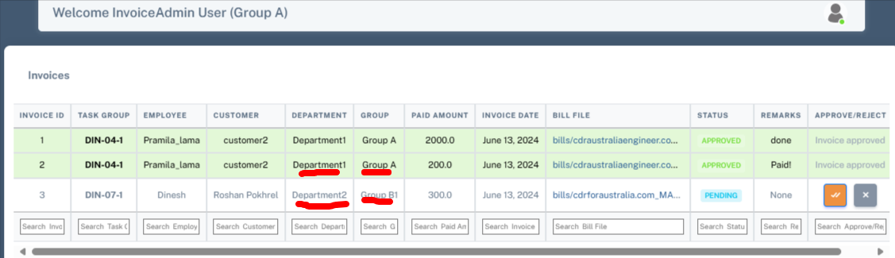

Invoice Admin will get all the invoices created.

Supervisor:

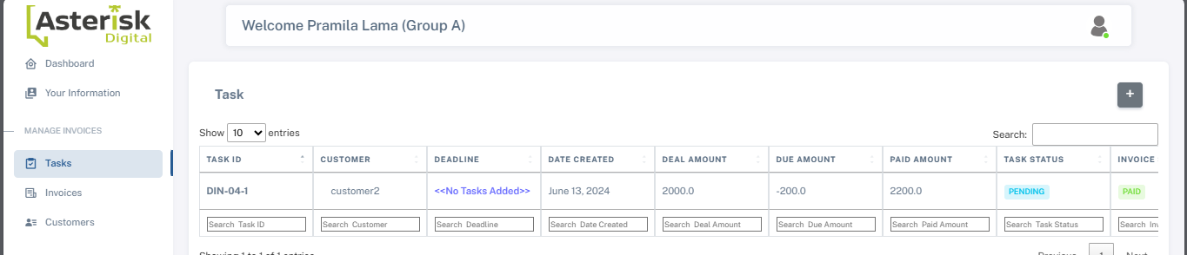

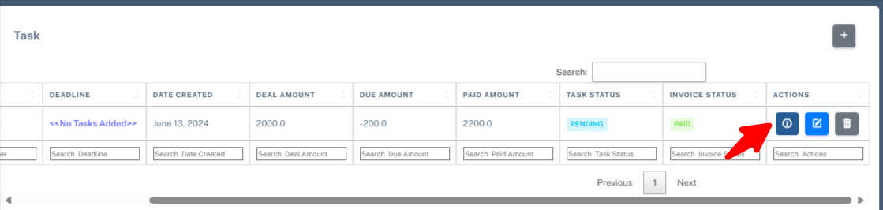

Click on the action and assign a task

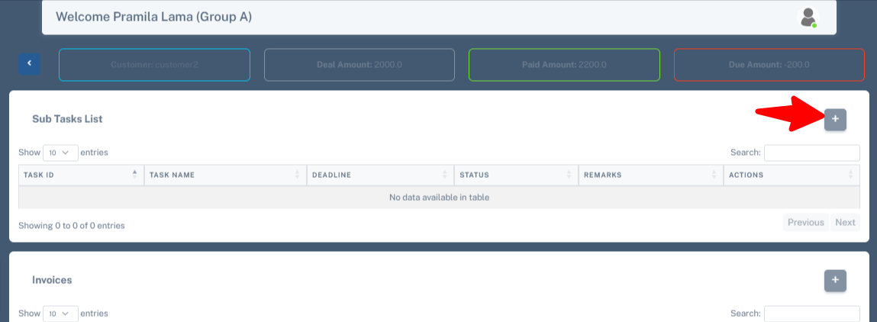

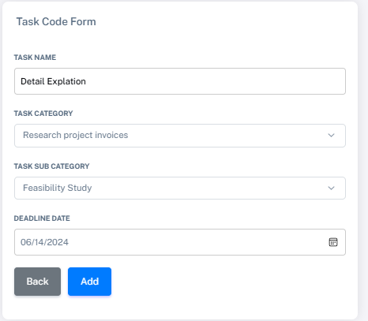

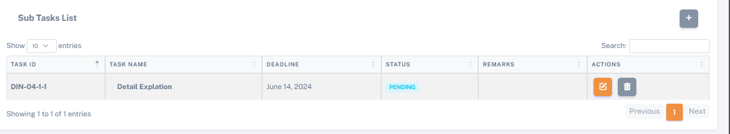

Supervisor is ready to approve task 👍

Let’s login to the supervisor 1 : Department 1, Group A1

Supervisor 2 : Department 2, Group B1

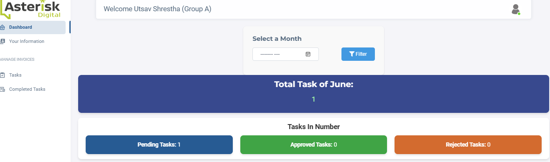

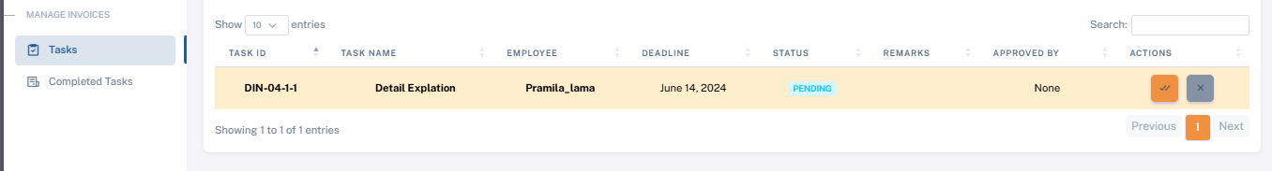

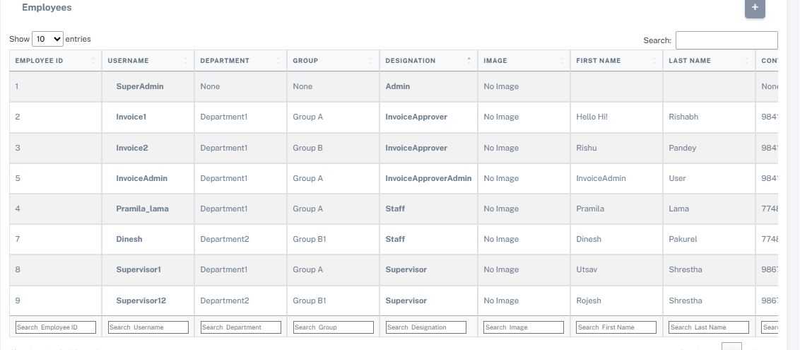

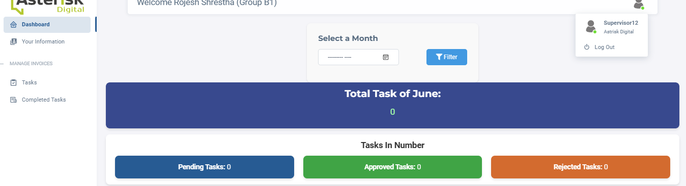

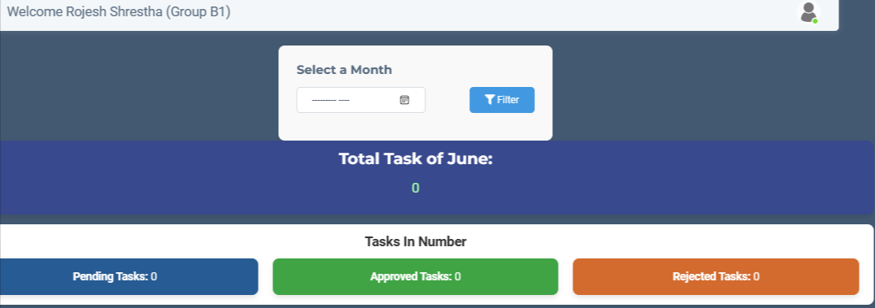

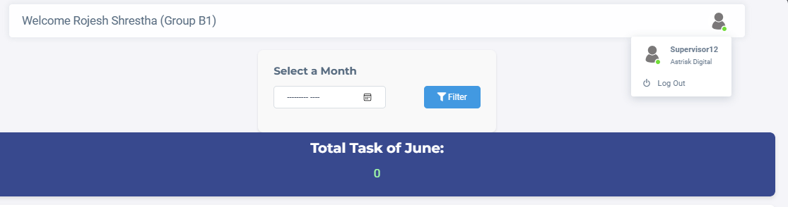

# Department Admin :

Admin for the supervisor , all the task assign with different dept and group will go the department admin.

